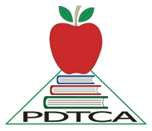Executive Board Meeting

Palliser District Teachers’ Convention Board
10:00 a.m. Palliser Hotel

November 21, 2014

- Call to order
- Approval of Agenda
- Approval of Minutes
- Correspondence
- Treasurer’s Report
- Reports
  - President
  - Vice President
  - Program
  - Facilities
  - Publicity/Booklet/Website
  - Exhibits
  - Past President
  - Secretary

- Old Business

- New Business
  - Fall Convention Meeting (November 27/14)
  - Fall PDAC (November 28, 29, 2014)
  - Evaluations Convention Meeting November (??????)
  - Convention Treasurer’s Seminar (??????)

- Local Concerns

